

Title of the proposed STC
Short Term Course on

WHO CAN PARTICIPATE
Short T
This short-term course is specifically designed for UG/PG/PhD students, researchers, faculties, and technical staff from the branches of engineering/ Science who are interested in the field of quantum communication systems, wireless communication systems, machine learning, artificial intelligence, quantum communication and information theory, quantum computing, data science, and predictive technologies.

REGISTRATION
Name: Designation: Institute: Address:

Email ID: Contact No: Undertaking:
I shall abide by rules and regulations and shall attend course. Failing which certificate may not be issued.

Signature of Participant

CONTACT

Dr. *******and Dr. *******
Assistant Professor
Department of ******* Engineering
Indian Institute of Technology (BHU), Varanasi
Email:***.***@itbhu.ac.in, ***.***@itbhu.ac.in

ABOUT NM-ICPS
The National Mission on Cyber-Physical Systems (NM-ICPS) is identified as one such emerging field to have a significant impact on health care, urban trans- portation, water distribution, energy, urban air quality, manufacturing and governance. The activities envi- sioned under this Mission will give an impetus to Indian manufacturing via the invention of new products, ser- vices and the creation of skilled young human resource from technicians to, researchers and entrepreneurs. It will have modernisation and digitalisation of socio- technical systems and services.

ABOUT I-DAPT
The Interdisciplinary Data Analytics and Predictive Technologies (I-DAPT) has been regarded as one of the most prominent fields whose progress will add signifi- cant impact on various socio-economic issues. At IIT (BHU) the verticals 1) Telecommunications, 2) Power, 3) Road Transport and Highways, 4) Defense Research and Development, 5) Health and Family Welfare and 6) Other Areas such as Energy, Environment and Agri-Tech have been identified under IDAPT. The endeavour shall catalyse the creation of skilled young engineers, researchers, technicians, and entrepreneurs, together with human resource at all levels, besides becoming a key contributor to realizing the vision of “Digital India”, “Innovate in India”, and “Make in India”.
Telecommunications Research & Development in I-DAPT
Telecommunications Research & Development in IDAPT aims at providing technology development support in the area of communication systems such as a) physical layer design for future communication system, b) Internet of things, c) quantum communication, d) machine based communication system design, e) THz communication system design, f) Molecular communication, etc. To achieve these goals, this program will give participants with a platform to learn about the next generation communication technologies.
.

A TECHNOLOGY INNOVATION HUB
nd
ON
INTERDISCIPLINARY DATA ANALYTICS AND PREDICTIVE TECHNOLOGY (IDAPT)
Under
NATIONAL MISSION ON INTERDICIPLINARY CYBER PHYSICAL SYSTEM (NM-ICPS)

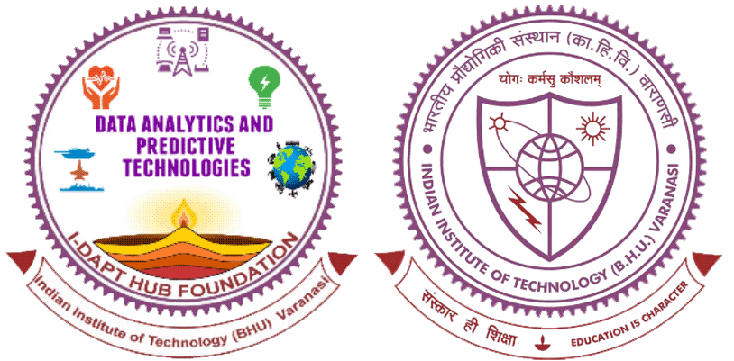

Month DD-DD, Year

Coordinators Dr. *******
Dr. *******

REGISTRATION DETAILS

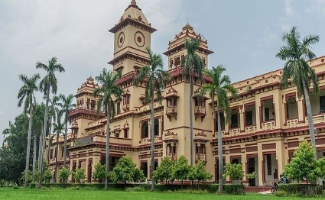
ABOUT INSTITUTE EMINENT SPEAKERS

The Indian Institute of Technology (Banaras Hindu Uni- versity) owes its exist- ence to Mahamana Pandit Madan Mo- han Malviya, Bharat Ratna-the founder of
the first residential university of modern India, the Banaras Hindu University. The three of the erst- while engineering colleges of BHU, namely BEN- CO, MINMET and TECHNO, were merged to form the Institute of Technology (IT-BHU) in 1968 to provide an integrated educational base. The IT- BHU has been admitting students through the JEE conducted by the IIT's since 1972, and has been consistently ranked amongst the top few engineer- ing institutions of the country. IT-BHU became IIT (BHU) in June 29, 2012 by an Act of Parliament. The Institute has maintained high academic standard since its inception. It has turned out luminary engineers and administrators who served the nation with great distinction.
ABOUT ECE
Department of Electronics Engineering (ECE) at Indian Institute of Technology (IIT BHU), where experienced faculty and highly motivated students supported by a dedicated staff experience a unique engineering education. The Department offers Bachelor, Master, and Doctoral programs in Electronics Engineering with the major thrust areas of Microelectronics, Microwave Engineering, Digital Techniques and Instrumentation and Communication Systems. In addition, continuing education programmers in specialized areas are offered on a regular basis for industry professionals and academic staff.
- Prof. P. K. Upadhyay (IIT Indore)
- Prof. Maurizio Magarini (Politecnico di Milano, Italy)
- Prof. Massimiliano Pierobon (University of Nebraska-Lincoln, USA)
- Prof. Teemu Myllylä (University of Oulu Finland)
- Prof. Preetam Kumar (IIT, Patna)
- Dr. Abhishek Dixit (IIT Delhi)
- Dr. Amritanshu Pandey (IIT (BHU) Varanasi)
- Dr. Atul Kumar (IIT (BHU) Varanasi)
- Dr. Sonam Jain (IIT (BHU) Varanasi)

COURSE CONTENTS (Tentative)
Quantum communication and machine learning is a rapidly growing field and lots of breakthroughs have been achieved during the past decades. Quantum communication is transitioning from an emerging branch of science into a mature research field in science and engineering. Under this STC, we will explore how to achieve secure communication for wireless networks in the presence of quantum technologies. The usage ranges are oriented to the new merging technology such as big data analytics, artificial intelligence, privacy-aware computing, hybrid human-machine computing, and distributed ledger technology. This STC will cover:
- Introduction, Background of Machine learning
- Statistical modelling of ML algorithms
- Use of ML for AI in communication system
- Introduction, Background of quantum communication
- Quantum communication-based system design
- quantum information theory
- Applications to quantum communication
- Hands-on ML algorithms using python
- Use of ML for Quantum communication system design

Registration Link:
https://www.idapthub.org/applications/stc

Last Date of Registration: October 20, 2023
Registration Fees (Including 18% GST)
Participation | Online | Offline
For UG, PG and PhD students: | Rs. 750 | Rs. 1,500
Staff (Technical, Administrative and Others | Rs. 1,500 | Rs. 3,000
For faculties, scientists and Post-doctoral Fellow | Rs. 2,000 | Rs. 4,000
Industry Participants | Rs. 3,500 | Rs. 7,000
International Participants | USD 100 | NA

NOTE Registration fees will be Non-Refundable

Payment Mode:
Branch: SBI, IT(BHU), Varanasi IFSC: SBIN0011445
Name: I-DAPT-HUB-FOUNDATION
Account No: 40298890505

Course Mode:
Both online and offline
In case of any difficulty, you can contact us at
Mobile number;
xxx.xxxx@iitbhu.ac.in, xxx.xxxx@itbhu.ac.in

